COGNIA
INTELLIGENT COGNITIVE
ALARM PLATFORM
Full Project Documentation

Project Detail | Information
Project name | COGNIA – Intelligent Cognitive Alarm Platform
Application type | Web application
Frontend | React.js
Backend | Python with FastAPI
Database | MongoDB
Machine learning | Scikit-learn Decision Tree Classifier for adaptive difficulty
Authentication | JWT-based authentication and role handling
Containerization | Docker and Docker Compose
Repository branch | kavinayaa

Table of Contents
- 1. Abstract
- 2. Introduction
- 3. Problem Statement
- 4. Objectives
- 5. Scope
- 6. Existing and Proposed Systems
- 7. Technology Stack
- 8. System Architecture
- 9. Module Description
- 10. Data and Database Design
- 11. Adaptive Difficulty and Habit Scoring
- 12. API and Swagger Documentation
- 13. User Interface and Workflows
- 14. Testing and Validation
- 15. Docker Deployment
- 16. Security Considerations
- 17. Requirements Mapping
- 18. Limitations and Future Enhancements
- 19. Conclusion

1. Abstract
COGNIA is an Intelligent Cognitive Alarm Platform designed to encourage consistent wake-up habits by combining alarm scheduling with short cognitive challenges. Instead of relying only on a conventional alarm sound, the platform provides challenge-based interactions such as mathematics, logic, memory, word games, pattern recognition, riddles, and quick quizzes. Challenge results and user behaviour can be used to inform adaptive difficulty, habit analytics, and personalized recommendations.
The implemented web application uses React.js for the user interface, FastAPI for REST APIs, MongoDB for persistence, JWT-based authentication, and a Scikit-learn Decision Tree Classifier for adaptive challenge difficulty. The system includes user dashboards, alarm and habit workflows, challenge history, analytics, Wellness Coach monitoring, and report functionality. Docker Compose runs the frontend, backend, and MongoDB as separate containers.
This report distinguishes implemented core functionality from items in the broader specification that are not fully implemented, such as OAuth2 social login, a React Native mobile app, full notification infrastructure, PostgreSQL integration, and cloud hosting.

2. Introduction
A regular wake-up routine can be difficult to maintain when users repeatedly snooze alarms or dismiss them without becoming fully alert. COGNIA aims to make waking up more interactive by requiring users to engage with a cognitive task. It also brings alarm management, habit tracking, sleep information, challenge performance, and recommendations into one web platform.
The platform is intended for students, professionals, and other users who want to improve routine consistency and cognitive engagement. A Wellness Coach view supports monitoring of registered users. The current implementation is a browser-based web application rather than a native mobile application.

3. Problem Statement
Conventional alarms generally provide limited support for building a consistent wake-up routine. They do not necessarily encourage active engagement, track challenge performance, or summarize long-term patterns in one place. Users may also lack feedback about their wake-up behaviour, snooze patterns, sleep schedule, and habit progress.
COGNIA addresses this problem by combining configurable alarms, cognitive challenges, behavioural tracking, adaptive difficulty, habit scoring, analytics, and recommendations in a single application.

4. Objectives
- Provide secure registration/login and role-aware access to the web application.
- Allow users to configure alarm times, alarm types, challenge types, and difficulty levels.
- Present cognitive challenges and record challenge outcomes.
- Use performance-related features to recommend an appropriate next challenge difficulty.
- Display wake-up, challenge, habit, and sleep-related analytics where data is available.
- Calculate and display a weighted habit score.
- Provide AI-assisted guidance and progress recommendations.
- Offer Wellness Coach monitoring of registered users.
- Integrate the frontend, backend, and MongoDB and run them using Docker Compose.
- Provide API exploration and testing through FastAPI Swagger UI.

5. Scope

5.1 Included in the current implementation
- React.js web frontend with Dashboard, Alarms, Habits, Challenges, Analytics, Profile, Login/Register, and Wellness Coach views.
- FastAPI backend and REST endpoints.
- MongoDB persistence for application data.
- JWT-based authentication and role information.
- Alarm creation and management options.
- Cognitive challenge selection, evaluation, and history.
- Adaptive difficulty recommendation using a Decision Tree Classifier.
- Habit score and behavioural analytics views.
- Sleep and wake-up analytics views when records exist.
- AI recommendation messages and report download functionality.
- Docker Compose services for frontend, backend, and MongoDB.

5.2 Outside the verified current scope
- Native Android/iOS application built with React Native.
- OAuth2 social sign-in providers.
- Full Firebase Cloud Messaging, Android Alarm Manager, and iOS local-notification integration.
- A fully developed administrator dashboard.
- A production-grade PostgreSQL plus MongoDB dual-database architecture.
- AWS/Azure public-cloud deployment; Docker runs locally and is not itself proof of public cloud hosting.
- A complete Excel/PDF export suite unless each export format has been separately verified.

6. Existing and Proposed Systems

6.1 Existing system
A conventional alarm application usually focuses on setting a time and playing an alert. It may provide limited cognitive engagement and may not combine challenge performance, habit scoring, adaptive difficulty, and wellness analytics.

6.2 Proposed system
COGNIA combines alarm configuration with cognitive tasks and analytics. The application records relevant activity, presents summary metrics, and uses an adaptive-difficulty component to recommend a challenge level. Users can review their own dashboard, while the Wellness Coach page provides a view of registered users.
Area | Conventional alarm | COGNIA approach
Wake-up interaction | Dismiss or snooze | Cognitive challenge-based interaction
Challenge types | Usually none | Math, logic, memory, word, pattern, riddle, quiz options
Personalization | Limited | Difficulty recommendation based on available performance signals
Habit feedback | Limited | Habit score and analytics views
Monitoring | Basic alarm list | User dashboard and Wellness Coach view
Deployment | Standalone app | React + FastAPI + MongoDB with Docker Compose

7. Technology Stack
Layer | Technology | Purpose
Frontend | React.js / JavaScript | Web pages, forms, dashboard, navigation, analytics displays
Backend | Python / FastAPI | REST endpoints, validation, business logic, analytics responses
Database | MongoDB | Persist user, alarm, habit, challenge, and history records as used by the app
Authentication | JWT | Token-based authentication and role-aware application access
Machine learning | Scikit-learn Decision Tree Classifier | Recommend the next cognitive challenge difficulty
Charts / visualization | Frontend chart components/canvas-based charts as implemented | Show metrics and trends
API testing | FastAPI Swagger UI | Explore and test API endpoints at /docs
Containerization | Docker, Docker Compose | Run frontend, backend, and MongoDB services
Version control | Git and GitHub | Source control and repository collaboration

8. System Architecture
The application uses a frontend–backend–database structure. The browser loads the React frontend. The frontend sends HTTP requests to FastAPI. FastAPI applies application logic, accesses MongoDB, and returns JSON responses. The adaptive-difficulty endpoint provides a recommended level based on the available model inputs and history.
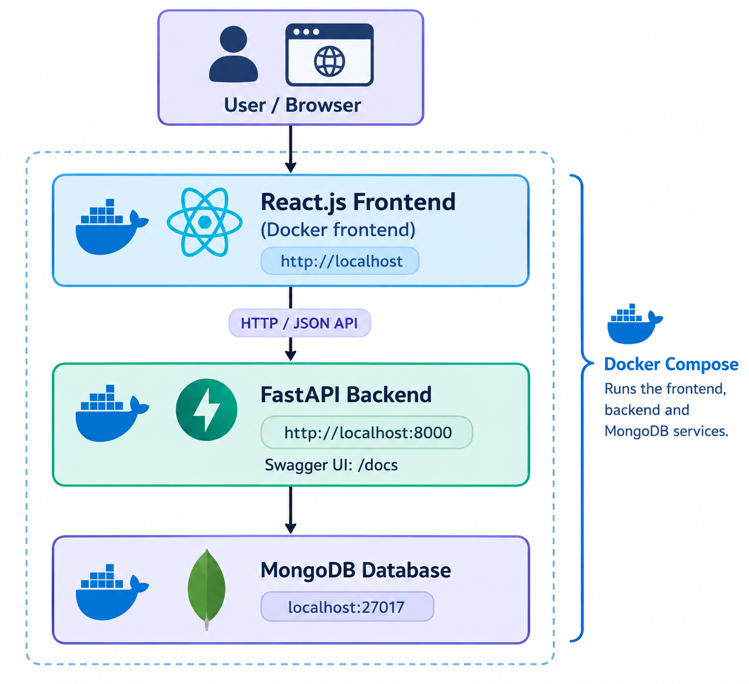

8.1 Main request flow
- The user opens the React web application and signs in.
- The frontend calls FastAPI endpoints for dashboard, alarms, habits, challenges, or analytics data.
- The backend reads or writes the relevant MongoDB records.
- The backend returns JSON results to the frontend.
- The frontend updates the relevant cards, lists, charts, and status indicators.
- The adaptive-difficulty endpoint returns a recommendation for the next challenge level.

9. Module Description

9.1 Authentication and role handling
Registration/login screens and JWT-related authentication are part of the application. The UI uses stored login information such as email and role to identify the current user and protect user-specific views. OAuth2 social-provider login is not verified as implemented.

9.2 User profile and habit management
The Habits/Profile area allows the user to record routine preferences such as preferred wake-up time, sleep duration, productivity goal, challenge difficulty, and habit preference, according to the implemented form fields.

9.3 Alarm scheduling
The Alarms page provides alarm creation options including time, alarm type, cognitive challenge type, and difficulty. The UI shows active alarms and a next-alarm summary. Actual operating-system-level background ringing is distinct from creating and displaying an alarm in the web application and should be demonstrated only if verified in the running build.

9.4 Cognitive challenge engine
The Challenges page provides challenge categories such as Math, Logic Puzzle, Memory, Word Game, Pattern Recognition, Riddle, and Quick Quiz, with difficulty choices from Beginner to Expert. The application checks submitted answers and records challenge history.

9.5 Adaptive difficulty engine
The adaptive endpoint uses a Scikit-learn Decision Tree Classifier to return a recommended next difficulty and associated model metadata, based on the inputs/history available to the implementation. It is a prototype adaptive model, not a claim of a clinically validated or large-scale learning system.

9.6 Wake-up verification
Challenge completion is used as a verification interaction in the alarm workflow. More advanced anti-snooze and wakefulness-assessment methods—such as multiple consecutive answers, timed sequences, or mobile-device-level verification—should be treated as future work unless separately confirmed in code.

9.7 Behavioural analytics
Analytics screens summarize available challenge performance, wake-up counts, snoozes, habit measures, and sleep records. Empty or zero values can appear when no relevant events have been recorded.

9.8 Habit scoring
The system displays a weighted habit score and component indicators. The specification's proposed weights are wake-up consistency 35%, challenge completion success 25%, snooze reduction 20%, and sleep schedule adherence 20%. The displayed score depends on the actual data and formulas in the current backend.

9.9 Recommendation engine
The dashboard/analytics provides recommendation messages about challenge difficulty, wake-up consistency, sleep records, and routine improvement. These are rule/model-assisted recommendations rather than a claim of a separately deployed large language model.

9.10 User dashboard
The dashboard presents overall score, wake-up success, challenge accuracy, alarm totals, habit score, next alarm, adaptive AI details, behavioural analytics, sleep information, AI insight, and milestone status.
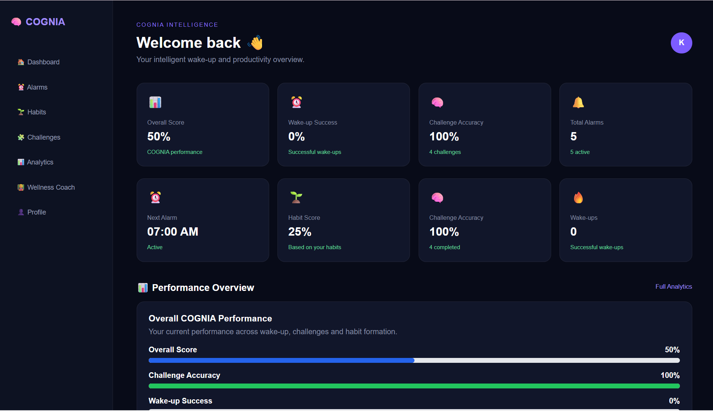

9.11 Wellness Coach
The Wellness Coach page lists registered users and shows profile information such as name, email, role, and account creation time. A monitoring panel communicates that wellness analytics can be reviewed; the exact depth of per-user drill-down depends on the implemented routes.

9.12 Reports and export
The Analytics page includes a Download Report control. The actual generated file format and contents should be verified in the running application before documenting it as PDF or Excel export.

9.13 API documentation
FastAPI's automatically generated Swagger interface allows available routes to be inspected and invoked. It is accessible locally at http://localhost:8000/docs while the backend is running.

10. Data and Database Design
MongoDB is the current database used by the application. MongoDB stores JSON-like documents grouped into collections. The following are logical data groups identified from the project workflow; exact field names should be confirmed against the current backend models and database.
Logical collection / entity | Purpose / example fields
users | User identity, email, password hash or authentication metadata, role, created timestamp
alarms | Owner email/user ID, alarm time, alarm type, challenge type, difficulty, active status
habits | User routine preferences, sleep duration, productivity goal, difficulty and habit preferences
challenges | Challenge content/type, difficulty, correct answer or validation data
challenge_history | User, challenge, result, completion time, timestamp, difficulty
wakeup_history | Wake-up attempts, successful verification, timestamp, snooze-related data where recorded
sleep records | Sleep duration, target duration, schedule adherence or quality fields where supported

The collection names above are logical documentation labels based on the project context; verify exact names and schema in MongoDB Compass or backend code before using this table as a database schema specification.

11. Adaptive Difficulty and Habit Scoring

11.1 Adaptive difficulty
The application uses a Decision Tree Classifier to produce a recommended difficulty level. A decision tree learns decision rules from training examples and assigns a class based on feature values. In COGNIA, the recommendation is intended to reflect available challenge and behavioural signals. The dashboard may display model name, confidence, accuracy, attempts analysed, and next recommended difficulty when those fields are returned by the backend.
A displayed model confidence or accuracy is not, by itself, proof that the model generalizes well to new users. For a production evaluation, the model should be tested on a separate held-out dataset and monitored over time.

11.2 Habit score
The project specification proposes the following weighted model:
Component | Weight | Interpretation
Wake-up consistency | 35% | How consistently the user wakes near the preferred time
Challenge completion success | 25% | Successful completion of cognitive tasks
Snooze reduction | 20% | Lower snooze behaviour contributes positively
Sleep schedule adherence | 20% | How closely sleep activity follows the target schedule
Total | 100% | Weighted habit score

A simplified conceptual formula is: Habit Score = 0.35 × Wake-up Consistency + 0.25 × Challenge Success + 0.20 × Snooze Reduction + 0.20 × Sleep Adherence. Each component should be normalized to a common 0–100 scale. The exact implementation should be checked in the backend before asserting that the formula is applied exactly as written.

11.3 Handling missing data
If the user has not yet completed wake-up verification or recorded sleep sessions, related analytics may show zero, N/A, or a prompt to record data. This is expected for an empty history and should not be interpreted as a failed API unless the backend logs or response indicate an error.

12. API and Swagger Documentation
FastAPI exposes an interactive API page generated from the backend route definitions. When the backend container is running, open:
http://localhost:8000/docs
Swagger shows the actual routes available in the running backend. The following endpoint patterns have been used in the frontend code shared for this project:
Endpoint pattern | Purpose
GET /dashboard/{email} | Load user dashboard and statistics
GET /adaptive-difficulty/{email} | Retrieve adaptive difficulty recommendation
GET /analytics/dashboard/{email} | Load analytics dashboard data
GET /coach/users | Load users for the Wellness Coach view

These are endpoint patterns observed in the shared frontend code; use Swagger as the source of truth for the complete and current route list. The report intentionally does not invent HTTP methods or routes for every module.

12.1 Suggested API demo
- Open /docs and show the available route groups.
- Expand a dashboard or analytics endpoint and select Try it out if applicable.
- Use a valid test account identifier in the format expected by the endpoint.
- Execute the request and show the response code and JSON response.
- Return to the frontend and show the corresponding dashboard or analytics section.

13. User Interface and Workflows
Page | Purpose | Demo action
Login / Register | Authenticate or create a user account | Sign in using a test account
Dashboard | Summary of alarms, habit score, challenge accuracy, wake-up metrics, adaptive recommendation | Point out metric cards and AI insight
Alarms | Create and view alarms | Create a test alarm and show it in the list
Habits | Set routine and productivity preferences | Show saved routine values and habit components
Challenges | Select and solve a cognitive challenge | Answer a question and show the result/history
Analytics | Challenge, habit, wake-up, sleep, adaptive and report views | Show charts, metrics, and download control
Wellness Coach | List registered users for monitoring | Show user identity and role information
Swagger | Inspect and execute backend APIs | Open http://localhost:8000/docs

13.1 End-to-end demo sequence
- Start the Docker Compose services and confirm that all containers are Up.
- Open http://localhost and log in.
- Create an alarm with a selected time, challenge type, and difficulty.
- Open Challenges and solve a sample question; show the completion/history result.
- Open Dashboard and Analytics to show the updated metrics and adaptive recommendation.
- Open Wellness Coach to show the registered user list.
- Open Swagger UI to show backend API documentation.
- Run docker compose ps in the terminal to prove that frontend, backend, and MongoDB are running in containers.

14. Testing and Validation
The project has been run locally with Docker Compose, and the reported container status showed the frontend, backend, and MongoDB containers running. The frontend production build also completed successfully after correcting JSX closing tags. The following table is a recommended test checklist; it is not a claim that every test has been formally automated.
Test case | Expected result | Status / evidence
Frontend production build | Vite build completes without JSX errors | Reported successful build; large-bundle warning may remain
Docker Compose startup | Frontend, backend, MongoDB containers start | Reported all three containers Up
Frontend access | COGNIA web interface loads | Local URL: http://localhost
Swagger access | API documentation loads | Local URL: http://localhost:8000/docs
Login flow | Valid user can sign in | Verify live during demo
Alarm creation | Alarm is saved and listed | Verify live during demo
Challenge evaluation | Answer result and history are shown | Previously observed challenge history
Analytics display | Available metrics load; missing data is handled | Observed analytics page; values depend on stored records
Adaptive recommendation | Difficulty and model details are displayed when returned | Observed Decision Tree Classifier details
Wellness Coach | Registered users are listed | Verify live during demo

For a formal release, also test invalid login, missing fields, unauthorized access, malformed API requests, database unavailability, duplicate actions, and browser refresh/navigation. Record actual results rather than marking unexecuted tests as passed.

15. Docker Deployment
Docker containerization packages the application services into isolated containers. Docker Compose coordinates the services and their network configuration. The current local setup reports three containers: frontend, backend, and MongoDB.
Container | Service | Reported port mapping | Role
cognia-frontend | frontend | 80:80 | Serves the built React web application through Nginx
cognia-backend | backend | 8000:8000 | Runs the FastAPI application
cognia-mongodb | mongodb | 27017:27017 | Stores application data

The port mappings above reflect the reported docker compose ps output. Actual configuration should be checked in docker-compose.yml.

15.1 Commands
docker compose up -d --build
docker compose ps
docker compose logs -f backend
docker compose logs -f frontend
docker compose logs -f mongodb
docker compose down
Do not run docker compose down during a live demo unless you intend to stop the application. Docker running locally is containerized deployment; it does not mean the app has been published on AWS, Azure, or a public website.

15.2 Local addresses
Service | Address
COGNIA website | http://localhost
FastAPI Swagger | http://localhost:8000/docs
MongoDB | mongodb://localhost:27017 (if host access is enabled)

16. Security Considerations
- Passwords should be stored as secure hashes, never as plain text; confirm the backend implementation.
- JWT tokens should be signed with a secret stored outside source control and configured safely.
- Backend routes should enforce authorization server-side; hiding a frontend link alone is not access control.
- Avoid exposing database ports or debug endpoints to the public internet in a production deployment.
- Use HTTPS and environment-based secrets for any public deployment.
- Validate and sanitize user input and avoid leaking internal exception details in API responses.
- Use synthetic/demo accounts during presentations and avoid displaying real credentials.

17. Requirements Mapping
Requirement group from specification | Current implementation assessment
Authentication and role handling | Core login/JWT and role information implemented; OAuth2 not verified
Profile and habit management | Core preference forms and habit views implemented
Alarm scheduling | Alarm creation/listing and multiple options implemented; verify actual background ringing and recurrence behaviour
Cognitive challenge engine | Challenge categories, answer checking, and history implemented
Adaptive difficulty | Decision Tree recommendation implemented
Wake-up verification | Challenge-based verification workflow; advanced methods may be partial
Behavioural analytics | Analytics screens for challenge/wake-up/snooze/habit signals where data exists
Habit scoring | Habit score and component display implemented; confirm exact backend formula
Recommendations | Recommendation messages and adaptive-difficulty guidance implemented
User and Wellness Coach dashboards | User dashboard and Coach user list implemented; full Admin dashboard not verified
Notifications and reminders | Full FCM/mobile notification infrastructure not verified
Reports and exports | Download Report control exists; confirm exact file format(s)
Integration and testing | Frontend/backend integration and successful local container startup reported; formal automated coverage not established
Docker containerization | Frontend, backend, and MongoDB reported running in Docker Compose
AWS/Azure cloud deployment | Not included in current local Docker setup
React Native mobile app | Not included; current frontend is React.js web
PostgreSQL | Not used in the current implementation described; MongoDB is the active database

The specification lists several technologies and capabilities as a broad target. The implementation should be presented honestly: do not claim that React Native, OAuth2, FCM, PostgreSQL, public cloud hosting, or a full Admin dashboard exists unless those features are actually added and tested.

18. Limitations and Future Enhancements
- Add a React Native mobile client if a mobile app becomes a mandatory deliverable.
- Integrate real mobile/local notifications and background alarm scheduling where platform policies permit.
- Add OAuth2 login if required by the evaluator.
- Build a full Admin dashboard with user management and platform-level reports.
- Implement and test explicit multi-step, consecutive-answer, time-based, and anti-snooze verification workflows.
- Validate the adaptive model on a representative held-out dataset and track real-world recommendation performance.
- Confirm and implement separate PDF and Excel report export formats if required.
- Add automated backend tests, frontend tests, and end-to-end tests.
- Add centralized logging, monitoring, backups, and environment-based secret management.
- Deploy to a public cloud only if requested and configure HTTPS, production database security, and CI/CD.

19. Conclusion
COGNIA demonstrates a web-based intelligent cognitive alarm workflow by combining user authentication, alarm configuration, cognitive challenges, adaptive difficulty recommendations, habit tracking, analytics, and Wellness Coach monitoring. The implemented stack—React.js, FastAPI, MongoDB, Scikit-learn, and Docker Compose—provides a coherent architecture for the current scope.
The reported local Docker status confirms that the frontend, backend, and MongoDB containers can run together. The project can be demonstrated through the website, Swagger UI, and Docker Compose status. Features from the broader specification that are not implemented should be clearly described as future enhancements rather than claimed as completed.

